**Business Requirement for ThinkFood**

Contents

1. System Overview 2

2. Requirements Scope 2

2.1 In Scope 2

2.2 Out of Scope 3

3. Functional Requirements 3

3.1 UML Use Case Diagram 4

3.2 UML Use Case Specifications 5

4. Non-Functional Requirements 13

5. Data Model 13

6. UI Screen Mockups 14

**Table of Figures**

Figure 1 - System Architecture 2

Figure 2 - Login Screen 4

Figure 2 - Data Model Diagram 13

Figure 3 - Cart 14

Figure 3 - Login Screen 15

## System Overview

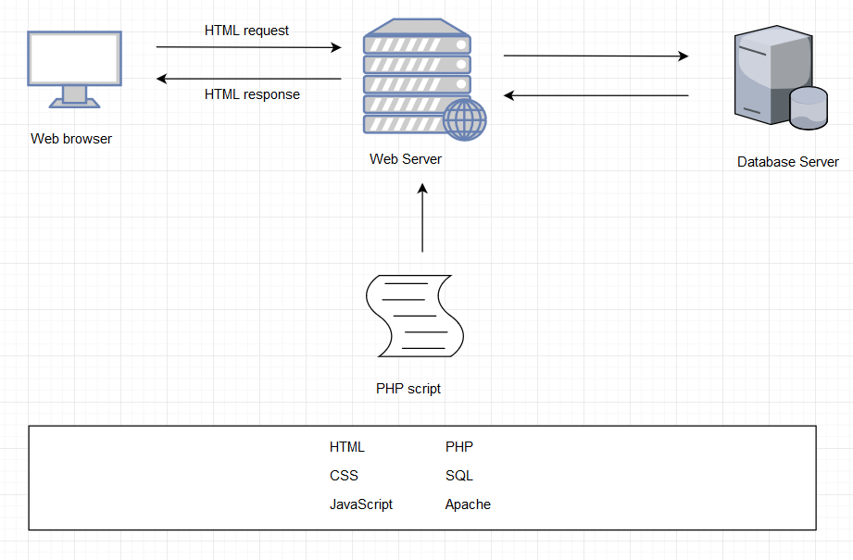

MY SQL

Figure 1 – System Architecture

## Requirements Scope

### In Scope

|  |  |
| --- | --- |
| **Requirement No** | **Description** |
| R01 | The client must be able to log into an admin account |
| R02 | The client must be able add products the web site |
| R03 | Must be able display products by categories |
| R04 | Customers must register place orders |
| R05 | display the current items in the cart |
| R06 | add selected products the cart |
| R07 | delete products (individually or all) from their cart |
| R08 | adjust the quantity of a selected product currently in the cart |
| R09 | preserve the contents of the cart if the user’s session is disconnected |
| R10 | have the cart accessible regardless from any machine the customer is logging in |
| R11 | provide a confirmation email sent the client after they place their order |
| R12 | include a secure, online payment process |
| R13 | Allow customers view their order history |
| R14 | Provide an intuitive, consistent look and feel the user interface |
| R15 | Use free open source software |
| R16 | Have the system fully tested and up and running in 8 weeks |
| R20 | Allow customers provide reviews for any of the products they have purchased |
| R21 | Must be able display the evaluation reviews for any products |
| R22 | Provide customers with appropriate product recommendations when they log in |
| R23 | Provide customers with any product recommendations when they look at a particular product |

### 2.2 Out of Scope

|  |  |
| --- | --- |
| **No** | **Requirement** |
| 1 | preserve the contents of the cart if the user’s session is disconnected accidentally |
| 2 | allow the order to be shipped ta different address and person other than the user |
| 3 | Allow customers change their order after they have created it |
| 4 | Allow customers change their registration information |

## Functional Requirements

* R01 – The client must be able to log in to an admin account
* R02 – The client must be able to add products to the web site
* R03 – Must be able to display products by categories
* R04 - Customers must register to place orders
* Must provide a fully functioning shopping cart utility where a customer can:
  + R05 – display the current items in the cart
  + R06 - add selected products to the cart
  + R07 - delete products (individually or all) from their cart
  + R08 - adjust the quantity of a selected product currently in the cart
  + R09 - preserve the contents of the cart if the user’s session is disconnected
  + R10 - have the cart accessible regardless from any machine the customer is logging in
  + R11 - provide a confirmation email sent to the client after they place their order
  + R12 - include a secure, online payment process
* R13 - Allow customers to view their order history

Extra:

* R20 – Allow customers to provide reviews for any of the products they have purchased
* R21 – Must be able to display the evaluation reviews for any products
* R22 – Provide customers with appropriate product recommendations when they log in
* R23 – Provide customers with any product recommendations when they look at a particular product

### 3.1 UML Use Case Diagram

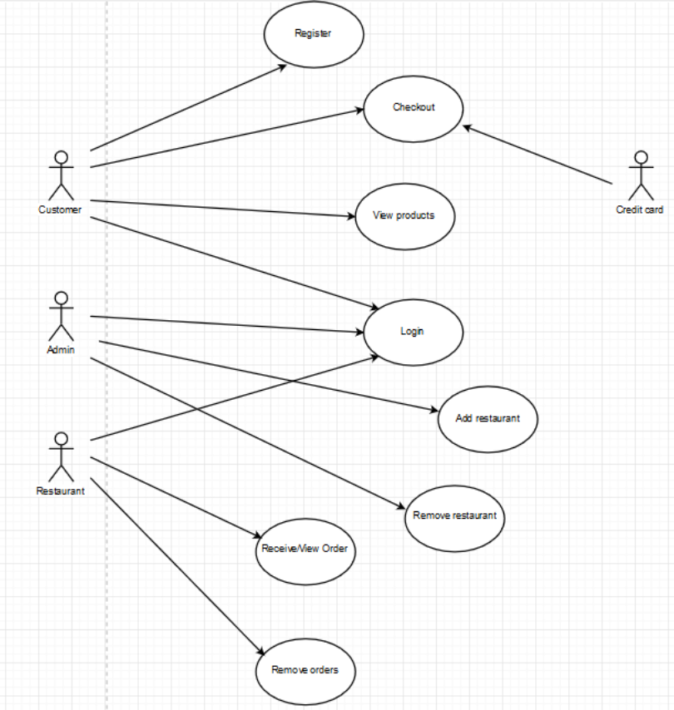

Figure 2 - Login Screen

### 3.2 UML Use Case Specifications

**Registration**

|  |  |  |  |
| --- | --- | --- | --- |
| **Use Case Name:** | User Account Registrations | **Use Case ID:** | UC001 |
| **Primary Actor:** | Customer | | |
| **Description:** | Customers fill out the mandatory items to register their accounts. | | |
| **Triggering Event:** | Log-in is necessary for making a purchase. Customer information is needed for delivery and payment. | | |
| **Steps Performed (Main Path)** | | | |
| 1. Click the register button on the website | | | |
| 1. Fill the personal information given | | | |
| 1. Customers are checking the information correctly typed by validation function | | | |
| 1. The information will be saved on the database | | | |
| 1. Let the user know that the registration has been approved | | | |
| **Extensions or Alternate Scenarios** | | | |
| 2a. Users can cancel the registration | | | |
| 2b. Users do not fill the personal information properly, warning pops | | | |
| **Pre-Conditions:** | The database server must connect to the registration session in the website. | | |
| **Post-Conditions:** | The customer can log in and view the products | | |
| **Assumptions:** | Customer is good standing within general registration | | |
| **Success Guarantee:** | 1.The customer can log in successfully with the account they just have created  2. The information is stored in the database without any violation | | |
| **Outstanding Issues:** | The connection could be lost during registration. | | |
| **Priority:** | HIGH | | |

**Check-Out**

|  |  |  |  |
| --- | --- | --- | --- |
| **Use Case Name:** | Check-Out the orders | **Use Case ID:** | UC002 |
| **Primary Actor:** | Customer, Credit Card | | |
| **Description:** | The customer can check out the amount of products using payment system | | |
| **Triggering Event:** | The customer selects the products and click the check-out button | | |
| **Steps Performed (Main Path)** | | | |
| 1. View the cart after shopping | | | |
| 2. The customers select the products and click the check-out button | | | |
| 3.The customers type the credit card number and extra information | | | |
| 4. The confirmation message will be sent to customers via an e-mail | | | |
| **Extensions or Alternate Scenarios** | | | |
| 3a. The customer put the wrong format of credit card | | | |
| 3b.The customer try to exit check-out session | | | |
| **Pre-Conditions:** | 1. The customers must be logged in 2. The customers must have their credit card | | |
| **Post-Conditions:** | The customer must get a confirmation email with a purchase receipt | | |
| **Assumptions:** | Customer is in good standing within the system. | | |
| **Success Guarantee:** | 1. After payment, customers and restaurants can receive the information | | |
| **Outstanding Issues:** | There is no response about the payment results | | |
| **Priority:** | HIGH | | |

**View Products**

|  |  |  |  |
| --- | --- | --- | --- |
| **Use Case Name:** | Customer Can View Products | **Use Case ID:** | UC003 |
| **Primary Actor:** | Customer | | |
| **Description:** | Customer can check products menu which includes product picture, price , review and rating | | |
| **Triggering Event:** | Customer selects the products | | |
| **Steps Performed (Main Path)** | | | |
| 1. After logging in, the customer can select the different category of food to make sure which restaurant they prefer. | | | |
| 1. The customer views menu from selected restaurants. | | | |
| 1. The customer can check the picture, price and rating for each product. | | | |
| 1. The customer can add selected products in their cart. | | | |
| 1. The customer can view, add or delete current order in cart | | | |
| **Extensions or Alternate Scenarios** | | | |
| 3a. When the customer select a product, there will be recommendation at the | | | |
|  | | | |
| **Pre-Conditions:** | 1. The customer must be connected to the system 2. The restaurant has already registered into the system | | |
| **Post-Conditions:** | The customer can view the product | | |
| **Assumptions:** | Customer is in good standing within the system. | | |
| **Success Guarantee:** | 1. The customer can check product picture, product price and product rating clearly after selected a restaurant. 2. The customer can check current recommendation for restaurant and dishes in main page 3. The customer can view/change the current order in their cart | | |
| **Outstanding Issues:** |  | | |
| **Priority:** | High | | |

**Log In**

|  |  |  |  |
| --- | --- | --- | --- |
| **Use Case Name:** | Logging in for Customer, Admin and Restaurant | **Use Case ID:** | UC004 |
| **Primary Actor:** | Customer, Admin, Restaurant | | |
| **Description:** | Customer, admin and restaurant can log in the system with different authorities | | |
| **Triggering Event:** | Customer, admin and restaurant can log in the system after they registered. | | |
| **Steps Performed (Main Path)** | | | |
| 1. Customer or Admin or restaurant owner open the system. | | | |
| 1. After they registered, they can access the system through log in page | | | |
| 1. After logged in, customer or admin or restaurant owner can enter different main page | | | |
| **Extensions or Alternate Scenarios** | | | |
| * 1. After customer log in, the website should base on the current main page with the recommendations | | | |
| * 1. After admin log in, they can manage restaurants and products | | | |
| * 1. After restaurant log in, they can manage the orders | | | |
| **Pre-Conditions:** | 1. All types of users log in with valid passwords | | |
| **Post-Conditions:** | 1. All users can be logged in with different authorities | | |
| **Assumptions:** | Customer /restaurant is a current user/business in good standing within the system. | | |
| **Success Guarantee:** | 1. The customer can log in and active successfully. 2. The admin can log in and active successfully. 3. The restaurant can log in and active successfully. | | |
| **Outstanding Issues:** | 1. User forgot the account information | | |
| **Priority:** | HIGH | | |

**Add Restaurant**

|  |  |  |  |
| --- | --- | --- | --- |
| **Use Case Name:** | Add restaurant | **Use Case ID:** | UC05 |
| **Primary Actor:** | Admin | | |
| **Description:** | Admin can add more restaurant to the website | | |
| **Triggering Event:** | Add restaurant button | | |
| **Steps Performed (Main Path)** | | | |
| 1. Admin login to the site | | | |
| 1. Admin choose add restaurant button | | | |
|  | | | |
|  | | | |
| **Extensions or Alternate Scenarios** | | | |
| 2a. Admin can cancel adding process. Go back to home screen | | | |
| 2b. Admin can add menus | | | |
| 2c. Admin will add restaurant’s information, contact, location, menu, price, etc… | | | |
|  | | | |
| **Pre-Conditions:** | 1. Admin must be connected to the website 2. Admin must chose add restaurant option | | |
| **Post-Conditions:** | Admin must fill all information for that restaurant and their products or added at least one restaurant | | |
| **Assumptions:** | Admin knows how to use and manage the site | | |
| **Success Guarantee:** | Admin added a restaurant successfully and the information is saved on the database | | |
| **Outstanding Issues:** | 1. Admin cannot add restaurant 2. Admin add a restaurant without important information | | |
| **Priority:** | High | | |

**Remove Restaurant**

|  |  |  |  |
| --- | --- | --- | --- |
| **Use Case Name:** | Remove restaurant | **Use Case ID:** | UC06 |
| **Primary Actor:** | Admin | | |
| **Description:** | Admin can remove restaurant on the website | | |
| **Triggering Event:** | Remove restaurant button | | |
| **Steps Performed (Main Path)** | | | |
| 1. Admin login to the site | | | |
| 1. Admin choose remove restaurant button | | | |
| **Extensions or Alternate Scenarios** | | | |
| 2a. Admin can cancel removing process. Go back to home screen | | | |
| 2b. Admin will choose which restaurant he/she wants to be removed then click delete button. | | | |
| 2c. Alert a confirmation message when delete button is clicked | | | |
| 2d. Admin can remove the products on each restaurant | | | |
| **Pre-Conditions:** | 1. Admin must be connected to the website 2. Admin must chose remove restaurant option | | |
| **Post-Conditions:** | Admin must choose at least one restaurant to be removed | | |
| **Assumptions:** | Admin knows how to use and manage the site | | |
| **Success Guarantee:** | Admin removed a restaurant successfully on the database | | |
| **Outstanding Issues:** | 1. Admin cannot remove restaurant 2. The restaurant’s information not deleted properly | | |
| **Priority:** | High | | |

**Receive and View Orders**

|  |  |  |  |
| --- | --- | --- | --- |
| **Use Case Name:** | Receive and View Orders | **Use Case ID:** | UC007 |
| **Primary Actor:** | Restaurant | | |
| **Description:** | The customer’s orders are sent to the restaurant view. The restaurant can view the orders they receive and cook it | | |
| **Triggering Event:** | When the customer made purchases | | |
| **Steps Performed (Main Path)** | | | |
| 1. The restaurant is logged in | | | |
| 1. Someone makes an order at their own category menu in the website | | | |
| 1. The confirmation of the order is completed | | | |
| 1. The system will be sent the order information to the restaurant view | | | |
| **Extensions or Alternate Scenarios** | | | |
| 2.a The customers canceled their order after payment | | | |
|  | | | |
|  | | | |
|  | | | |
| **Pre-Conditions:** | The restaurant must be register in the database, after that they just need to log in. They mush have the authority as a restaurant | | |
| **Post-Conditions:** | The restaurant has cooked the order they receive | | |
| **Assumptions:** | The restaurant is always logged in | | |
| **Success Guarantee:** | The restaurant will cook as the order they received | | |
| **Outstanding Issues:** | Does the system know if the restaurant’s menu is out of stock? | | |
| **Priority:** | High | | |

**Remove orders**

|  |  |  |  |
| --- | --- | --- | --- |
| **Use Case Name:** | Remove orders | **Use Case ID:** | UC008 |
| **Primary Actor:** | Restaurant | | |
| **Description:** | The restaurant can remove the orders they received | | |
| **Triggering Event:** | When the restaurant wants to remove the order | | |
| **Steps Performed (Main Path)** | | | |
| 1. The restaurant must be log in | | | |
| 1. The restaurant must have received the orders | | | |
| 1. The restaurant selects what orders they want to remove | | | |
| 1. The order selected is removed | | | |
| **Extensions or Alternate Scenarios** | | | |
| 3a. more than 1 orders could be removed at once | | | |
|  | | | |
|  | | | |
|  | | | |
| **Pre-Conditions:** | The restaurant must be logged in to the database, they also must have received the orders | | |
| **Post-Conditions:** | The restaurant erased the orders | | |
| **Assumptions:** | Restaurant can’t provide the product for some reason | | |
| **Success Guarantee:** | The restaurant has deleted the orders they received | | |
| **Outstanding Issues:** | 1. Does the system will recommend the other menu equivalent to the food they order? 2. The canceled order should be refunded to the customer | | |
| **Priority:** | Medium | | |

## Non-Functional Requirements

|  |  |
| --- | --- |
| No | Description |
| R14 | Provide an intuitive, consistent look and feel tthe user interface |
| R15 | Use free open source software |
| R16 | Have the system fully tested and up and running in 8 weeks |

## Data Model

*<Include your Entity Relation diagram that you create in MySQL Workbench here.*

*For Example:*

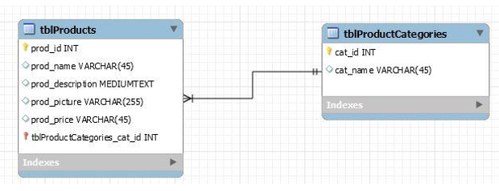

Figure 3 - Data Model Diagram

*>*

## UI Screen Mockups

*<Include your any screen mock-ups here for the web site, indicate which use case they are for*

*For Example*

*6.1 The following screen is for UC001 and shows the current contents of the shopping cart.*

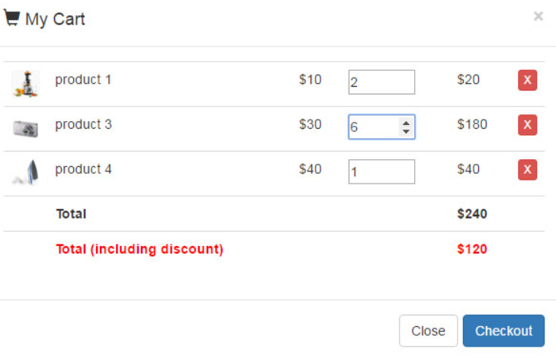

Figure 4 - Cart

*6.2 The following screen is the for use case UC002 and shows the login screen.*

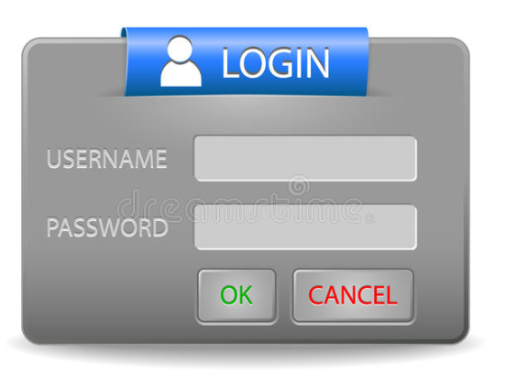

Figure 5 - Login Screen